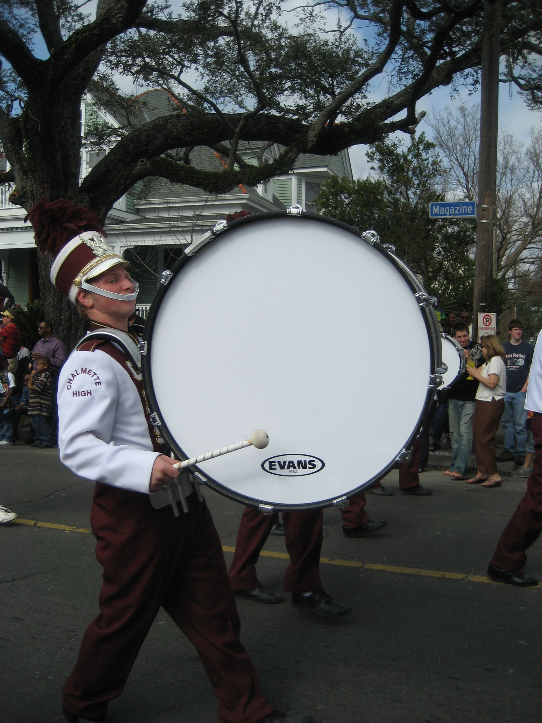
Speed of Sound with a Drum
Dan Burns (Idea from Brian Holmes)
Los Gatos High School
dburns@lgsuhsd.org

Introduction: With this activity your students can gain an appreciation for the speed of sound and be able to estimate it with a simple calculation. It makes a good test question too.

Procedure: Have a student beat a loud drum about 3 times a second at one end of a playing field. They should use exaggerated arm motions so that it can be easily seen when they strike the drum. Instruct your class to walk away, observing the drum being struck and listening for the sound. After awhile they will notice that the two are out of synch. Have them keep walking until the strike and the sound are back in synch. At this point it is taking about 1/3 of a second for the sound to reach them. Estimate the distance from this point to the drum, divide by 1/3, and you have the speed of sound. When all of your students are at this distance, signal the drummer to stop beating while everyone is watching. They will hear one more beat after the drummer stops.

Options: Have a student count the number of drumbeats over a 10 second interval to determine the time between beats more accurately. A long tape measure is useful for determining the distances. Since the distance is about 114 m, you can use the football field to help with the distance measurement. If you don’t have a loud drum, a hammer on a bar of metal works well. Just make sure the student has ear and eye protection. It is a good idea to videotape this exercise. Once edited, it can be used for discussion or to replace actually doing it if it is raining or you are pressed for time. A simpler variation is to have a student slam two cymbals together while students observe from 100 yards away. A zoomed in video can be used to measure the time delay between when the cymbals crash and when it is heard.

