Bungee Jump Lab

Name Period

Introduction: Your goal is to predict the total distance a bungee jumper will fall during a jump. This is important for bungee jumping companies to prevent their customers from being injured. You will use conservation of energy to make your prediction. Sample Problem 8-5 in your book will be especially helpful.
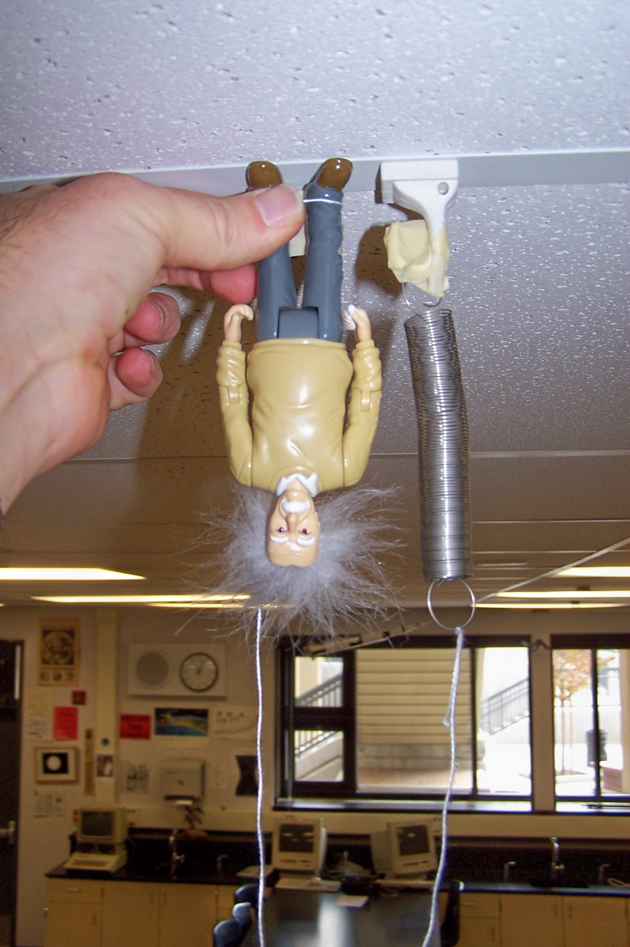
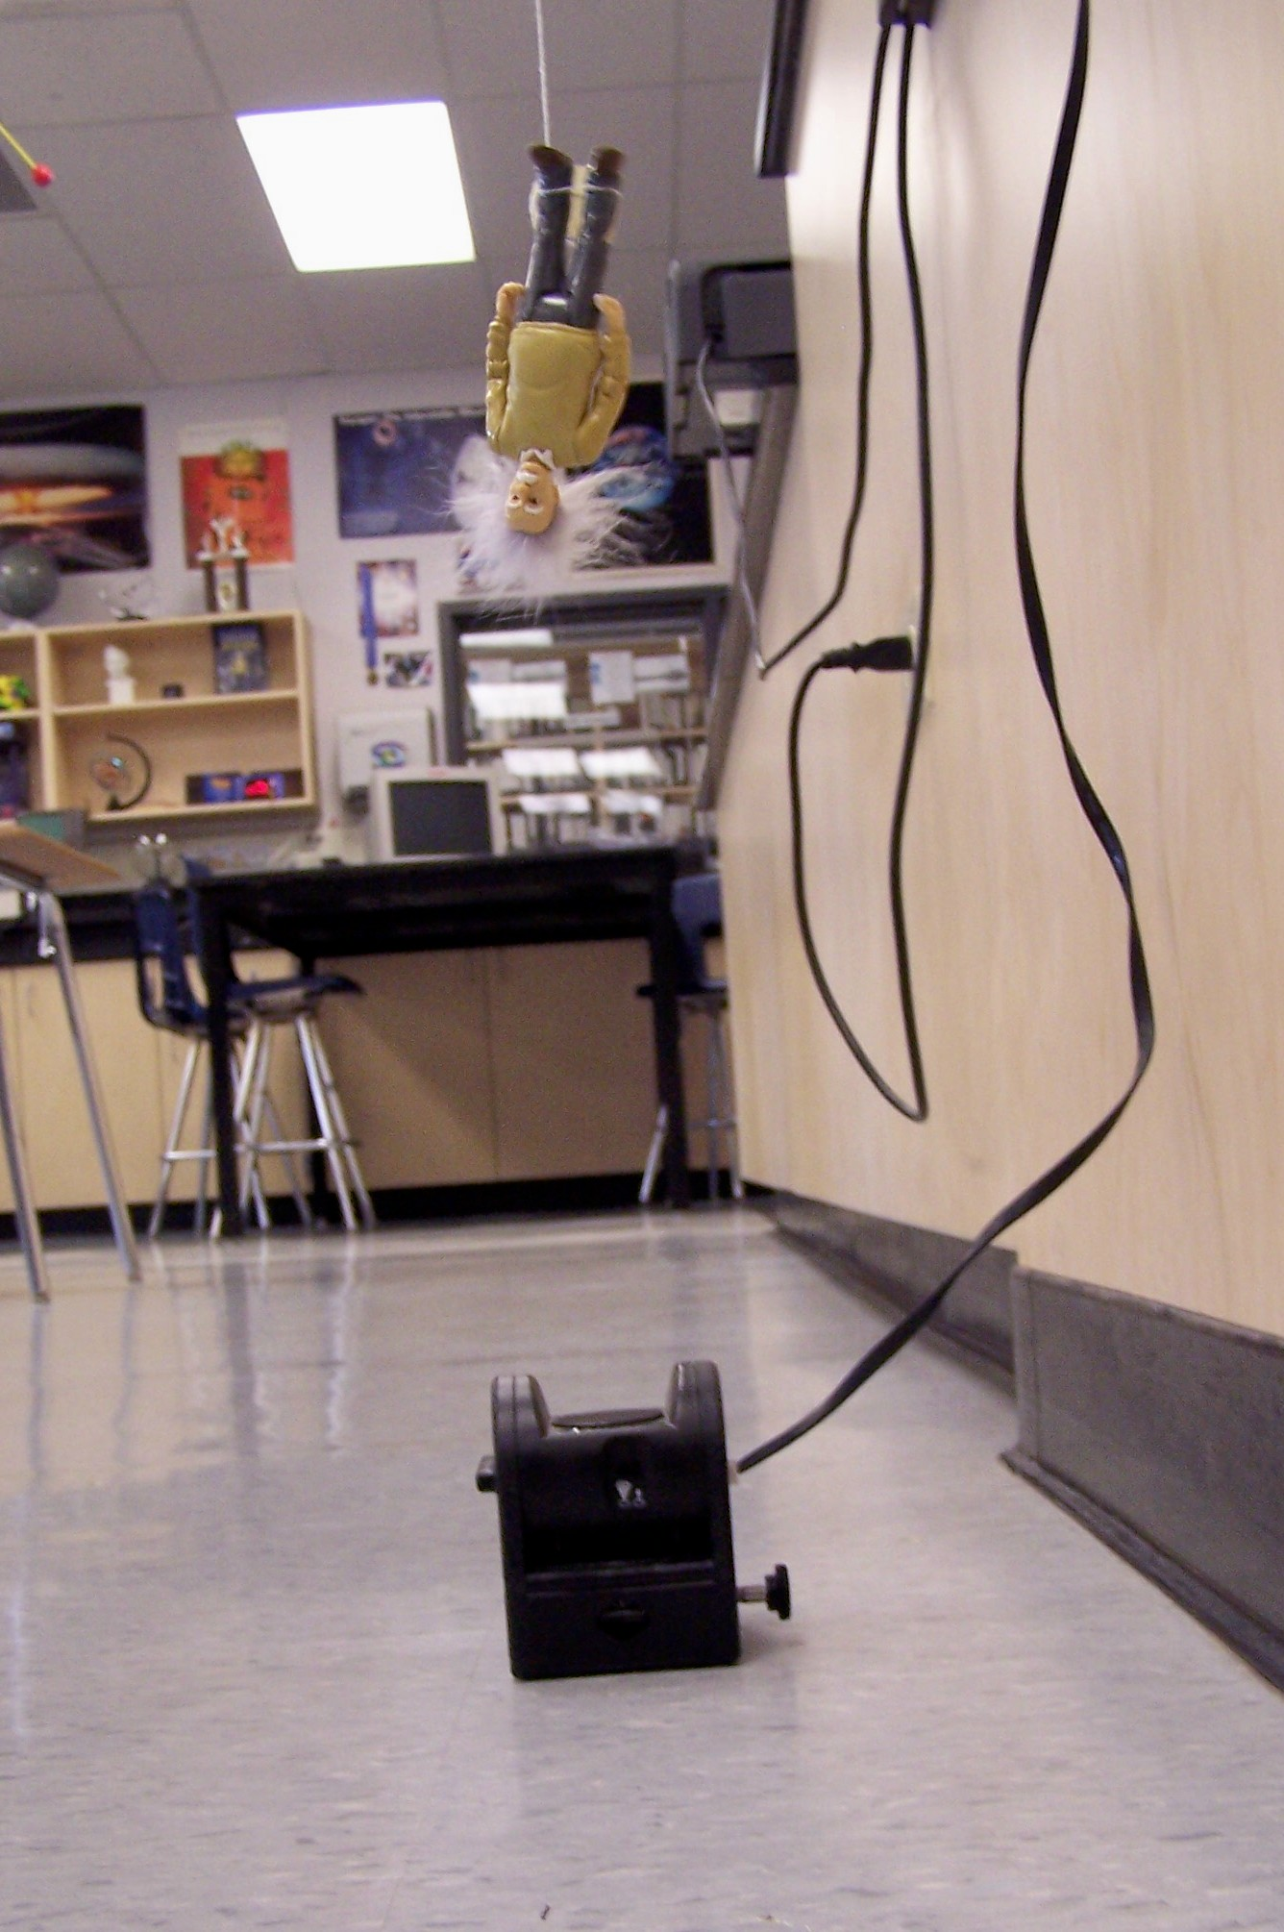
Problem Description: You will be given an Einstein action figure, a spring, a length of string, and a magnetic hook. The string connects Einstein’s feet to the spring. The spring is attached to the hook that is attached to one of the metal strips to the ceiling. You will place Einstein’s feet on the ceiling and then release him. Your goal is to predict how close Einstein’s head will get to a motion sensor placed on the floor. Your grade will be partially determined by how accurate your prediction is. See figures at right.

1. First you need to determine the spring constant, k. Set up a digit display of Force using Data Studio. Don’t forget to press the zero button on the force sensor. Record the force every 5 cm up to 50 cm in the data table below. Make sure you are always measuring relative to the end of the spring loop.

x (cm) | 0 | 5 | 10 | 15 | 20 | 25 | 30 | 35 | 40 | 45 | 50
x (m)
F_{s} (N)

2. Graph F_{s} Vs x on graph paper. F_{s} is on the y-axis and x should be in meters. Draw a best fit line with a straight edge. Pick 2 points ON THE LINE and calculate the slope. Show ALL of you work on your graph and attach it to your lab. The slope is the spring constant, k.

3. Measure and record anything else required to make your prediction below.

4. Describe and show in detail your procedure for making your prediction. Remember to consult Sample Problem 8-5. Read the hints given by your teacher on the board. A sketch showing Einstein the moment he is released and a sketch showing him at his lowest position is very useful.

Predicted Height above sensor: m

± 5 cm = +2 points, ± 10 cm = +1 point, ± 15 cm = +0 points, ± 20 cm = -1 point, ± 25 cm = -2 points,

Actual (to be filled out by teacher only): m

Q1: Use the figure at right to determine the equation for U_{E}, elastic potential energy. Show ALL of your work.

Q2: Look at your data table of spring force Vs stretch distance. Compare the force at x = 0.25 m and x = 0.50 m. How many times bigger is the force at x = 0.50 m?

Q3: Compare your spring constant to the force required to stretch your spring 0.5 m. How many times bigger is the spring constant? Why should it turn out this way? (look at the units of k and your answer to Q2)

Q4: Calculate the work done by you to stretch your spring 0.25 m. Calculate the work done by you to stretch the spring 0.50 m. How many times bigger is the x = 0.5 work? How can you explain this? (Hint: draw the two triangles representing the area of each on the Q1 graph)

Q5: Using Newton’s 2nd Law, determine the acceleration of the falling Einstein when the spring is stretched 0.25 m and when it is stretched 0.50 m. Don’t forget Einstein’s weight. Why are the accelerations different?

Q6: How high could your spring launch Einstein vertically if it was stretched to x = 0.5 m and all of the elastic potential energy is converted to kinetic energy?

Conclusion: Describe three things that use potential energy to do work on something.

