Elevators – The Ups and Downs of Newton’s Second Law

When do you Feel Heavy on an Elevator?

When do you Feel Light on an Elevator?

When do you Feel Normal on an Elevator?

Which situation(s) result in an upward acceleration?
A. Increasing speed on the way up
B. Increasing speed on the way down
C. Decreasing speed on the way up
D. Decreasing speed on the way down

Which situation(s) result in a downward acceleration?
A. Increasing speed on the way up
B. Increasing speed on the way down
C. Decreasing speed on the way up
D. Decreasing speed on the way down

Which situation(s) result in a zero acceleration?
A. When the elevator is at rest
B. When the acceleration has reached a steady positive value
C. When the acceleration has reached a steady negative value
D. When the elevator has a constant velocity

What will the scale read if the elevator has an upward acceleration of 2 m/s² ? Snowman mass = 50 kg Draw a free body diagram and solve for the normal force.

What is the acceleration if the scale reads 400 (N)? Snowman mass = 50 kg Draw a free body diagram and solve for the acceleration

Match the descriptions below to the numbered regions on the acceleration Vs time graph from an elevator ride, assume the elevator started from rest

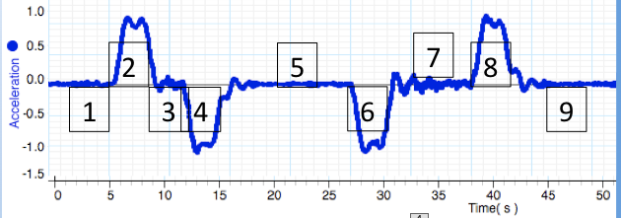
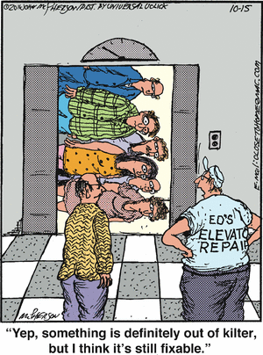
Decreasing speed on the way up ________

Elevator at Rest ________

Elevator moving at constant velocity ________

Increasing speed on the way up ________

Decreasing speed on the way down ________

Increasing speed on the way down ________

Fun Things to do on an Elevator:

http://scripting.com/davenet/stories/60FunThings.html

